After you add a file to the staging area, it is ready to be committed, but it won't be officially part of the **local repository** until you commit it.

**1. Working Directory (or Working Tree)**

* The **working directory** is the folder where you store your actual project files. These are the files you're actively editing, creating, or deleting.
* Files in the working directory can either be **tracked** (Git is aware of them and managing their history) or **untracked** (Git is not yet managing them).
* When you modify a file, the change is only in the working directory until you add it to the staging area using git add. and commit it.
* If you modify a **tracked file** in your working directory, **it is still tracked by Git**, but it won't be reflected in the **local repository** (in the commit history) until you commit the change.

**2. Local Repository (or Git Directory)**

* The **local repository** is a hidden directory inside your project folder called .git. It contains all the information Git needs to manage version control, such as commits, branches, and history.
* This repository stores the **commit history**, **staging area (index)**, **configuration files**, and other metadata.
* The **local repository** allows you to track changes, check the history of your project, and create commits.
* When you commit, Git saves the changes in the local repository, but these changes are not yet shared with others until you push them to a remote repository.

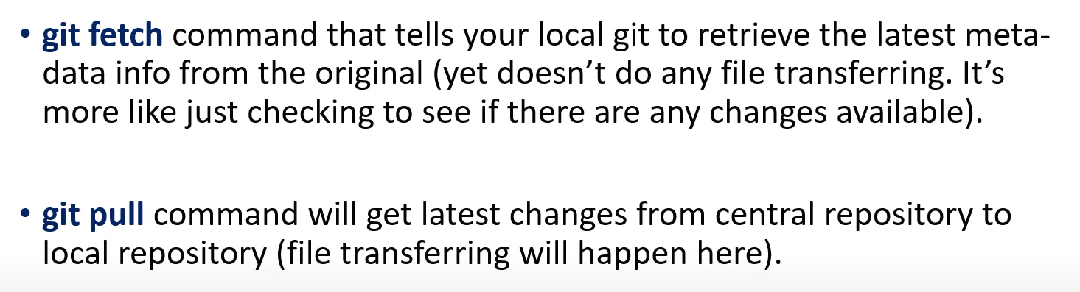

Git pull = Git fetch + Git merge

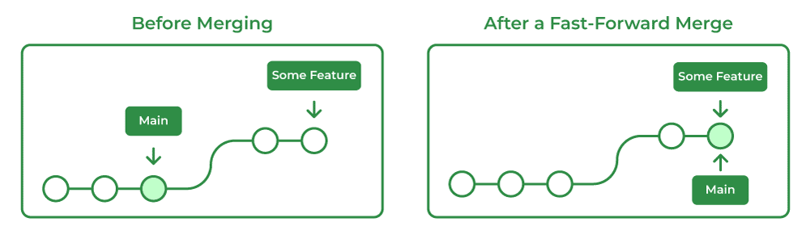

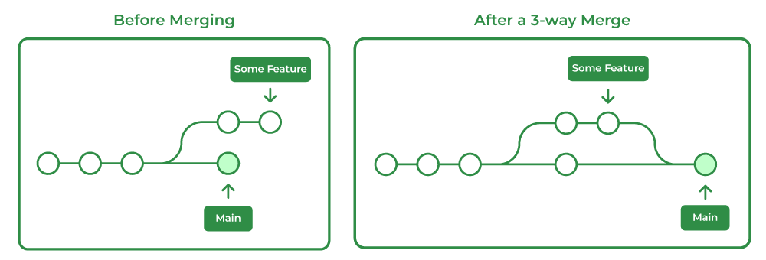

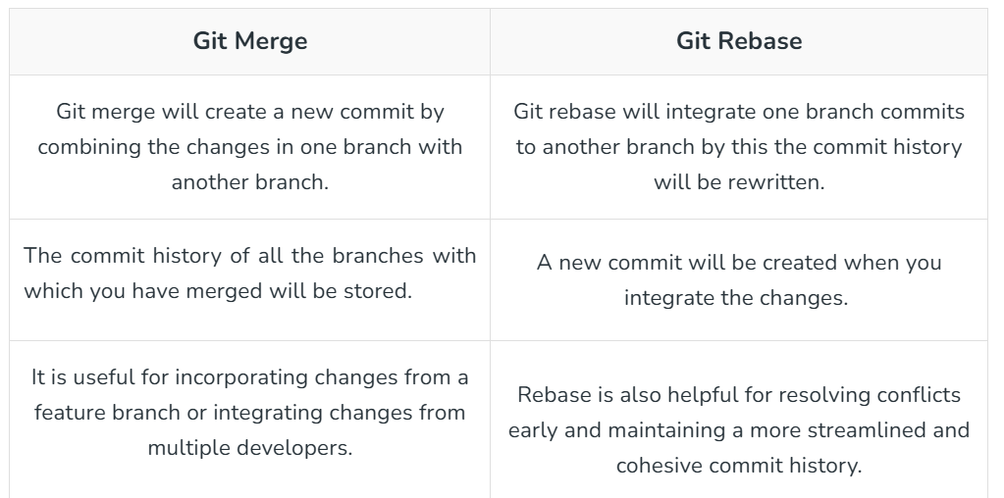

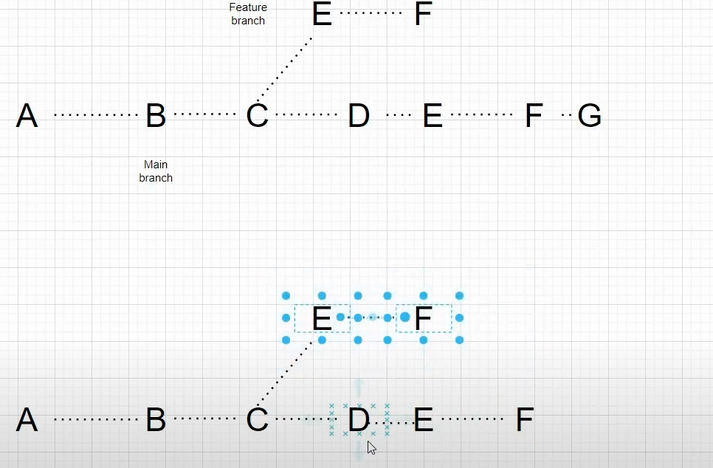 (Here, the names should be changed)

When we merge using git merge a new commit will be present ex. Merge branch “dev”



